Common API Security Methods - IP Whitelisting

🔐 What is IP Whitelisting
# Source: AI Source: Provided by: [Data Path: Persons Table -> ID Column: 1, Name_En Column: Motasem Essam] -> From: [ChatGPT] on [1/19/2026]
IP Whitelisting is a security technique where an API server allows access only from specific, trusted IP addresses and blocks all others.
👉 Think of it as a guest list: only approved IPs can enter, everyone else is denied.

🔑 Key Concepts
# Source: AI Source: Provided by: [Data Path: Persons Table -> ID Column: 1, Name_En Column: Motasem Essam] -> From: [ChatGPT] on [1/19/2026]
- Only pre-approved IP addresses can access the API
- Requests from unknown IPs are rejected automatically
- Works at the network/security layer

🧱 Example
# Source: AI Source: Provided by: [Data Path: Persons Table -> ID Column: 1, Name_En Column: Motasem Essam] -> From: [ChatGPT] on [1/19/2026]
Allowed Ips
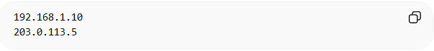
192.168.1.10
203.0.113.5
Request from Allowed IP
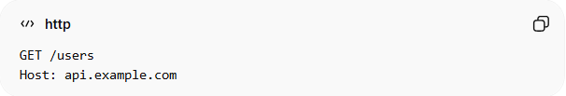
GET /users
Host: api.example.com
✅ Allowed

Request from Unknown IP
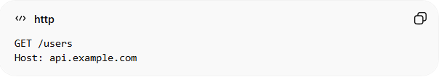
GET /users
Host: api.example.com
❌ Rejected → 403 Forbidden

⚙️ How It Works
# Source: AI Source: Provided by: [Data Path: Persons Table -> ID Column: 1, Name_En Column: Motasem Essam] -> From: [ChatGPT] on [1/19/2026]
- Client sends request
- Server checks client IP
- If IP is in whitelist → allow ✅
- If not → block ❌

✅ Advantages
# Source: AI Source: Provided by: [Data Path: Persons Table -> ID Column: 1, Name_En Column: Motasem Essam] -> From: [ChatGPT] on [1/19/2026]
- Simple and effective access control
- Adds an extra security layer
- Prevents unauthorized external access

❌ Disadvantages
# Source: AI Source: Provided by: [Data Path: Persons Table -> ID Column: 1, Name_En Column: Motasem Essam] -> From: [ChatGPT] on [1/19/2026]
- Not flexible for dynamic IPs (e.g., mobile users)
- Hard to manage at scale
- Not sufficient alone for full security

⚠️ Common Mistakes
# Source: AI Source: Provided by: [Data Path: Persons Table -> ID Column: 1, Name_En Column: Motasem Essam] -> From: [ChatGPT] on [1/19/2026]
- Relying only on IP whitelisting ❌
- Not updating IP list when infrastructure changes ❌
- Blocking legitimate users with changing IPs ❌

🔐 Best Practices
# Source: AI Source: Provided by: [Data Path: Persons Table -> ID Column: 1, Name_En Column: Motasem Essam] -> From: [ChatGPT] on [1/19/2026]
- Combine with OAuth / JWT / API Keys
- Use for internal APIs or trusted partners
- Regularly update and audit whitelist
- Log blocked access attempts

💡 Key Idea
# Source: AI Source: Provided by: [Data Path: Persons Table -> ID Column: 1, Name_En Column: Motasem Essam] -> From: [ChatGPT] on [1/19/2026]
IP Whitelisting restricts API access to trusted sources, adding a strong layer of protection but should be combined with other security methods.

🧾 Real Use Case
# Source: AI Source: Provided by: [Data Path: Persons Table -> ID Column: 1, Name_En Column: Motasem Essam] -> From: [ChatGPT] on [1/19/2026]
- Internal company APIs
- Communication between microservices
- Partner integrations with fixed server IPs

